These instructions explain how to prepare and format your paper for the digital submittal. Please make sure to read and follow them carefully. Please use this guide and template for your paper submission, and delete the yellow-highlighted part before your submission.
. Please do not forget to upload your paper to easy chair.

The document template
Title (should be bold, Times New Roman, bold, size 13)
Author’s Name*, Author’s Name** (e.g. Jane Doe*. Font should be: Times New Roman, 11 points).
* First author affiliation & Email address
** Second author affiliation& Email address
(e.g. *PhD, Department of Urban Planning, m.briek@tudelft.nl, Font should be: Times New Roman, 10 points, italic).
This document provides you with information on the layout and reference style of papers to be submitted to the 19th International Planning History Society Conference, July 4th to 6st. Please use the word styles as provided in this document. Use the ‘title paper’ style for the title of your paper, the ‘author’s names’ style for the names of the authors, the ‘author’s affiliations style’ for the affiliations of the authors, the ‘abstract text’ style for your abstract, the ‘keyword text’ style for the keywords, the ‘subtitle’ style for the subtitles and the ‘plain text’ style for the text of your paper. This is the place where you should write your abstract. An abstract should have a clear and convincing structure that sets up the research question, introduces the case study or argument, and ends with some meaningful conclusions. Please replace this text with your own text. The abstract should not exceed 200 words. Please do not forget that the abstract, the introduction, the main body of your paper, and the conclusion should be Times New Roman, 10 points.
Keywords: keyword 1, keyword 2, etc.

Introduction
Write your paper here, and please replace this text with your own text. The text area is defined in this document template, and it is based on an A4 sheet. Your paper should contain no less than 3000 words and should not exceed 4000 words (excluding abstract, notes, and bibliography). In addition, the document length for a paper must NOT exceed 12 PAGES, including references. Your paper should have an introduction and conclusion. Papers should be carefully edited in terms of style, grammar, and spelling. On matters of spelling and punctuation, we follow English rather than American style: thus, for example, colour/behaviour and familiarise/standardise. Please do not forget that the introduction font should be Times New Roman, 10 points.

Subtitles
Subtitles should be bold, Times New Roman, bold, size 10. Please use the ‘subtitle’ style for subtitles and ‘plain text’ style for plain text.

Referencing
Formatting follows the ‘Chicago’ endnote referencing style as used by the journal Planning Perspectives (Taylor and Francis). This means that instead of using footnotes or name-date ‘Harvard’ references, your manuscript will be referenced with short endnotes, which connect to an alphabetical bibliography listing all the sources and works on which it is based. More information on the Chicago Reference Style can be found here: http://www.chicagomanualofstyle.org/tools_citationguide.html.

Tables and Figures
It is important to illustrate your paper with a good spread of high quality images. Please embed the figures in your text. However, You are welcome to include up to 6 images to illustrate points made in your text. The resolution of the images should be at least 300 pixels/inch (ppi). All images should be accompanied by a corresponding brief caption referred to by a number following the order of appearance (Figure 1, 2, …), please see the example below. The sources of the images should be included in Image sources after the bibliography (please see below).

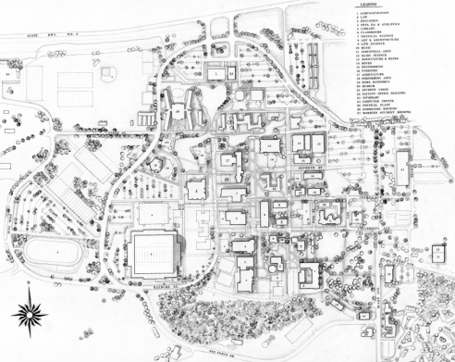
Figure 1 - Planning Study 1971. Several building types in this plan were constructed including the Hartung Theatre and College of Law. The ring road and proposed water feature are significantly different than what exists today

Acknowledgements
Please replace this text with your own. Please do not forget that the acknowledgements font should be Times New Roman, 10 points.

Disclosure Statement
No potential conflict of interest was reported by the author. Please do not forget that the text should be Times New Roman, 10 points.

Notes on contributor(s)
Write a short biography of the contributor(s). The text should not exceed 100 words. In addition, the text should be Times New Roman, 10 points.

Endnotes
Example:
… as documented by Hein. In addition, …... However ….
Sample: (the font should be Times New Roman, 8 points)

Carola Hein, Port Cities: Dynamic Landscape and Global Networks (New York: Routledge, 2011). 24.
Ibid. 25. Bibliography Include an alphabetical bibliography here. If you use endnote program, it will do it automatically. In addition, the font should be Times New Roman, 10 points. Hein, Carola. Port Cities: Dynamic Landscape and Global Networks. New York: Routledge, 2011. Image sources Figure 1: Library of Congress, Digital Archive [G7624.T4 1889 .M3]. Please consider that the Figure number, here, corresponds to the numbering used above. In addition, the font should be Times New Roman, 10 points.

